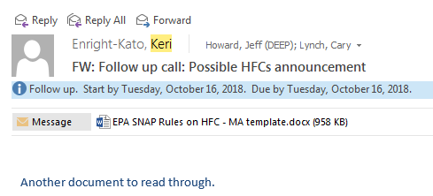**EPA SNAP Rules on HFC use**

***Background***

Under the authority of Section 612 of the Clean Air Act (CAA), the US EPA’s Significant New Alternatives Policy (SNAP) Program prohibits the use of ozone-depleting substances (ODS) and works with affected industries to identify and evaluate alternative chemicals, referred to collectively as ODS substitutes, that “reduce overall risks to human health and the environment.” The most common ODS substitutes, hydrofluorocarbons (HFCs), however, act as powerful greenhouse gases: just one pound of HFC-134a warms the planet as much as 1,400 pounds of carbon dioxide.

The EPA promulgated Rule 20 in 2015 and Rule 21 in 2016 to modify the status of certain HFCs and several other ODS substitutes from being acceptable alternatives to being unacceptable or acceptable subject to narrow use limits. But these rules were challenged in court. In August 2017, the D.C. Circuit Court of Appeals vacated Rule 20 “to the extent it requires manufacturers to replace HFCs” and remanded the rule to EPA for further proceedings consistent with the opinion that “Section 612 does not require (or give EPA authority to require) manufacturers to replace non-ozone depleting substances such as HFCs.”[1] The EPA issued guidance in April 2018 saying it lacked the authority to prohibit HFCs in all cases. In June 2018, Honeywell, Chemours (DuPont), and the Natural Resources Defense Council petitioned the US Supreme Court to reverse the August 2017 court decision.

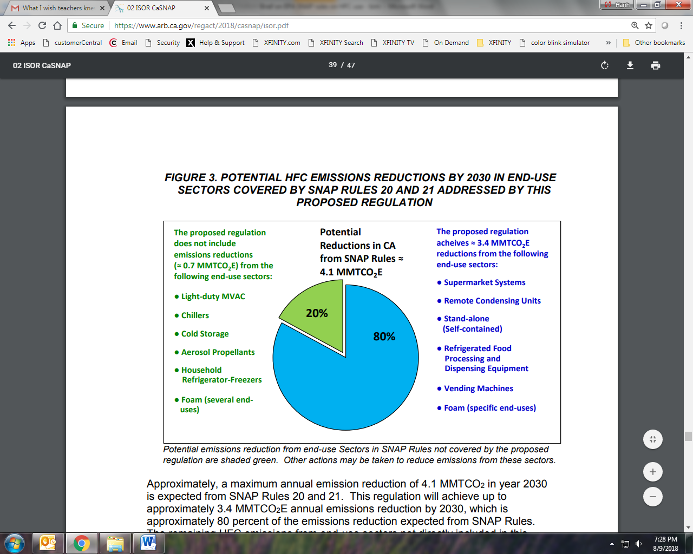

Source: <https://www.arb.ca.gov/regact/2018/casnap/isor.pdf>

The California Air Resources Board (CARB) proposed adopting parts of SNAP Rules 20 and 21 in March 2018 (see figure). The rulemaking has gone out to public comment, but has not yet been finalized. Since 2016, California has established other limits on HFC use, through Senate Bill 1383, which requires that California reduce its HFC emissions by 40% below 2013 levels by 2030.

Massachusetts does not currently limit HFC use. The [*Clean Energy and Climate Plan for 2020*](https://www.mass.gov/files/documents/2017/01/uo/cecp-for-2020.pdf) included a strategy to minimize emissions from high Global Warming Potential refrigerants (including HFCs) used in stationary non-residential equipment through leak detection and repair. In a separate effort, halogenated hydrocarbons C1-C 4 (including HFCs) were added in 2018 to the list of regulated chemicals under the Toxics Use Reduction Act, which requires large companies in Massachusetts that manufacture, process, or use regulated chemicals above a certain threshold to submit a Toxics Use Report annually, develop a plan to reduce the regulated chemicals, and pay an annual Toxics Use Fee.

***Potentially affected entities in MA*** *(additional information in Appendix)*

Rule 20, HFC provisions only:

* Entities manufacturing, selling, using, or servicing retail food refrigeration units/systems (i.e. supermarket systems, remote condensing units, and stand-alone units), motor vehicle air conditioning systems, vending machines, aerosol propellants, and foams.

Rule 21, HFC provisions only:

* Entities manufacturing, selling, using, or servicing retail refrigerated food processing and dispensing equipment, cold storage warehouses, new household refrigerators and freezers, various new chillers, spray foam & sealants, and closed cell foam products.

***Legal authority for state actions***

***Regulatory process & timeline***

***HFC emissions reduction estimates & broader process for GWSA compliance***

1. D.C. Circuit Court of Appeals decision on *Mexichem Fluor, Inc. v. EPA*: <https://www.eenews.net/assets/2017/08/08/document_gw_13.pdf>